**RESTful Web Services Assignments**

**Assignment – 1:**

**Web Service:** [**http://localhost:8080/Assignment_1/api/CreditCard/5005**](http://localhost:8080/Assignment_1/api/CreditCard/5005)



**Client: RestClient.java**

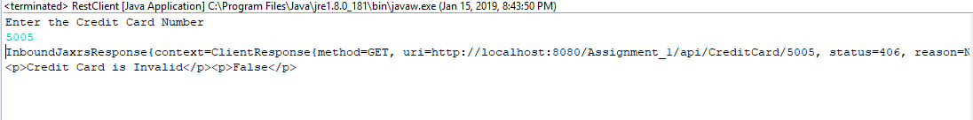

**Assignment – 2:**

**Web Service:** [**http://localhost:8080/Assignment_2/api/Date?day=15&month=11&year=1985**](http://localhost:8080/Assignment_2/api/Date?day=15&month=11&year=1985)

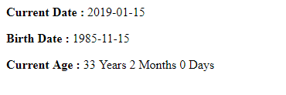

**Client: RestClient.java**

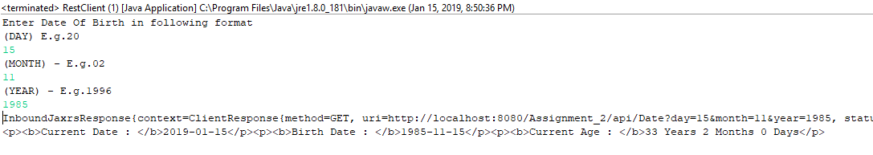

**Assignment – 3:**

**WebService:** [**http://localhost:8080/Assignment_3/api/integer?value=10**](http://localhost:8080/Assignment_3/api/integer?value=10)



**Client: RestClient.java**

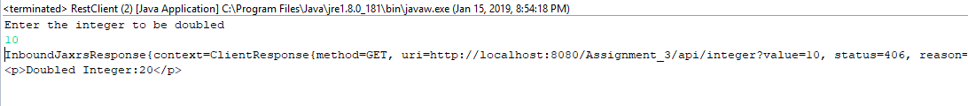

**Assignment – 4:**

**WebService:** [**http://localhost:8080/Assignment_4/api/lowercase?str=I%20AM%20A%20STRING**](http://localhost:8080/Assignment_4/api/lowercase?str=I%20AM%20A%20STRING)



**Client: RestClient.java**

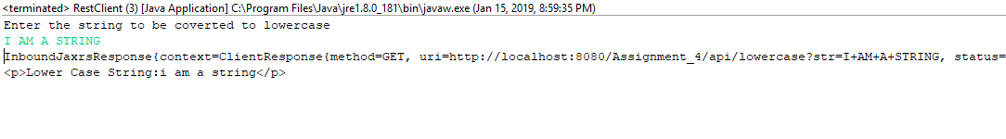

**Assignment – 5:**

**WebService:**

ADD: [**http://localhost:8080/Assignment_5/api/Calculate/add?num1=10&num2=20**](http://localhost:8080/Assignment_5/api/Calculate/add?num1=10&num2=20)

SUBTRACT: [**http://localhost:8080/Assignment_5/api/Calculate/subtract?num1=10&num2=20**](http://localhost:8080/Assignment_5/api/Calculate/subtract?num1=10&num2=20)

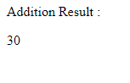

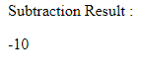

**Client :**

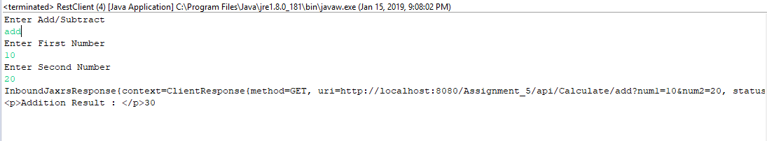

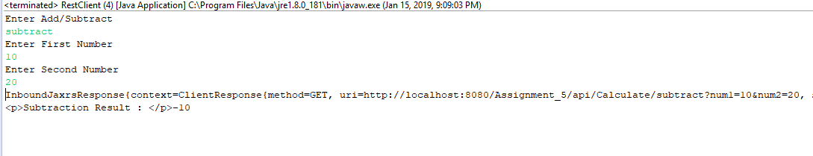

**Assignment – 6:**

**WebService:** [**http://localhost:8080/Assignment_6/rest/employees**](http://localhost:8080/Assignment_6/rest/employees)

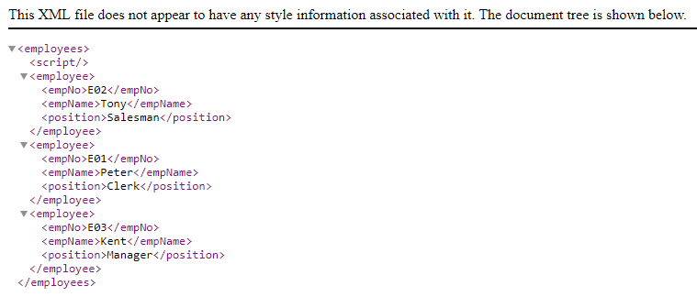

**Client:**

**Read– ReadClient.java**

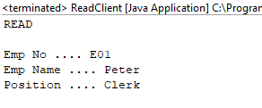

**Create – CreateClient.java**

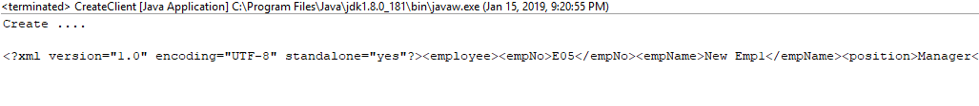

**Update – UpdateClient.java**

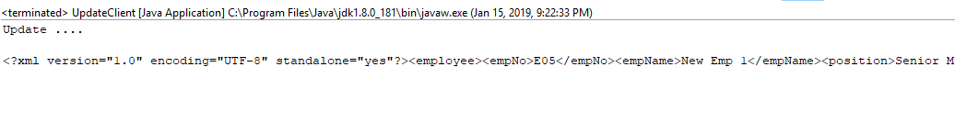

**Delete – DeleteClient.java**

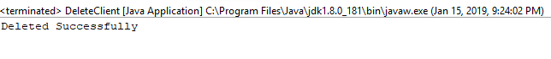

**Assignment – 7:**

**Web Service:** [**http://localhost:8080/Assignment_7/api/accounts**](http://localhost:8080/Assignment_7/api/accounts)

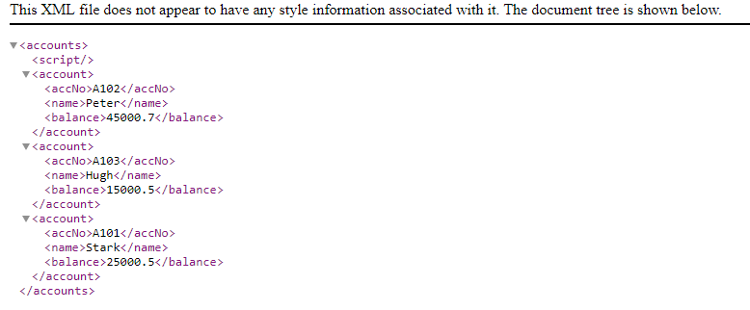

**Client:**

**Get Balance : GetBalanceClient.java**

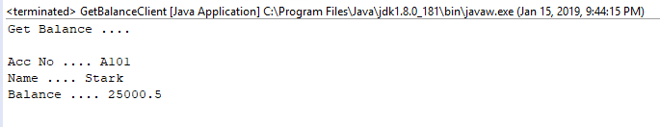

**Deposit : DepositClient.java**

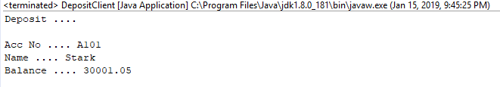

**Withdraw : WithdrawClient.java**

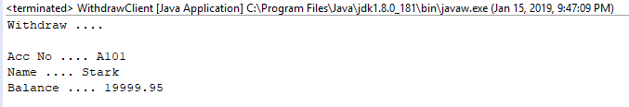

**Assignment – 8:**

**Web Service :** [**http://localhost:8080/Assignment_8/api/albums/toJSON**](http://localhost:8080/Assignment_8/api/albums/toJSON)



**Client :**

To access the Album details – **GetAlbums.java**

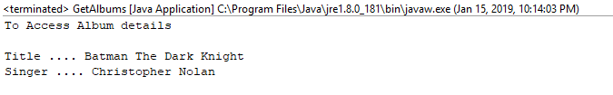

New Albums – **FromJSONPostClient.java**

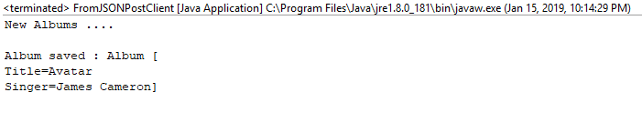

**Assignment – 9:**

**Web Service:** [**http://localhost:8080/Assignment_9/api/movies**](http://localhost:8080/Assignment_9/api/movies)

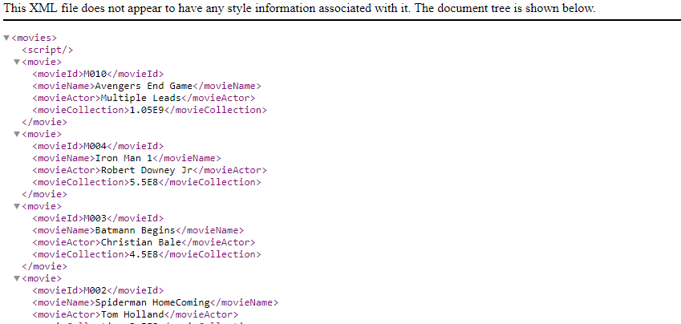

* “GET” method that returns all the movie objects in “text/xml” format

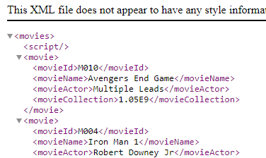

* “GET” method that returns all the movie objects in “application/xml” format

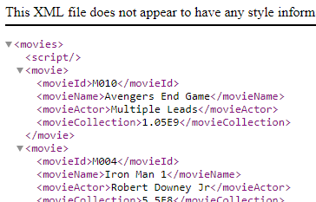

* “GET” method that returns all the movie objects in “application/json” format



* “GET” method that takes a “movieId” as the argument and returns only the Movie details for that MovieId in “application/xml” format.

